Unzip the build check the test folder

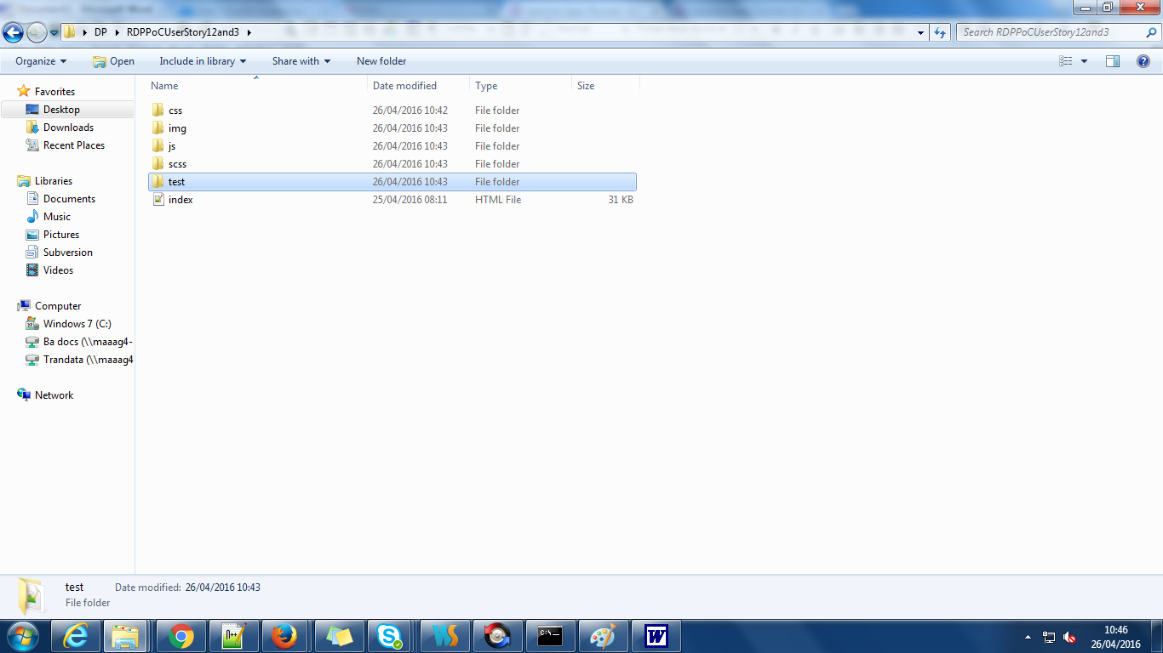

Open the test folder

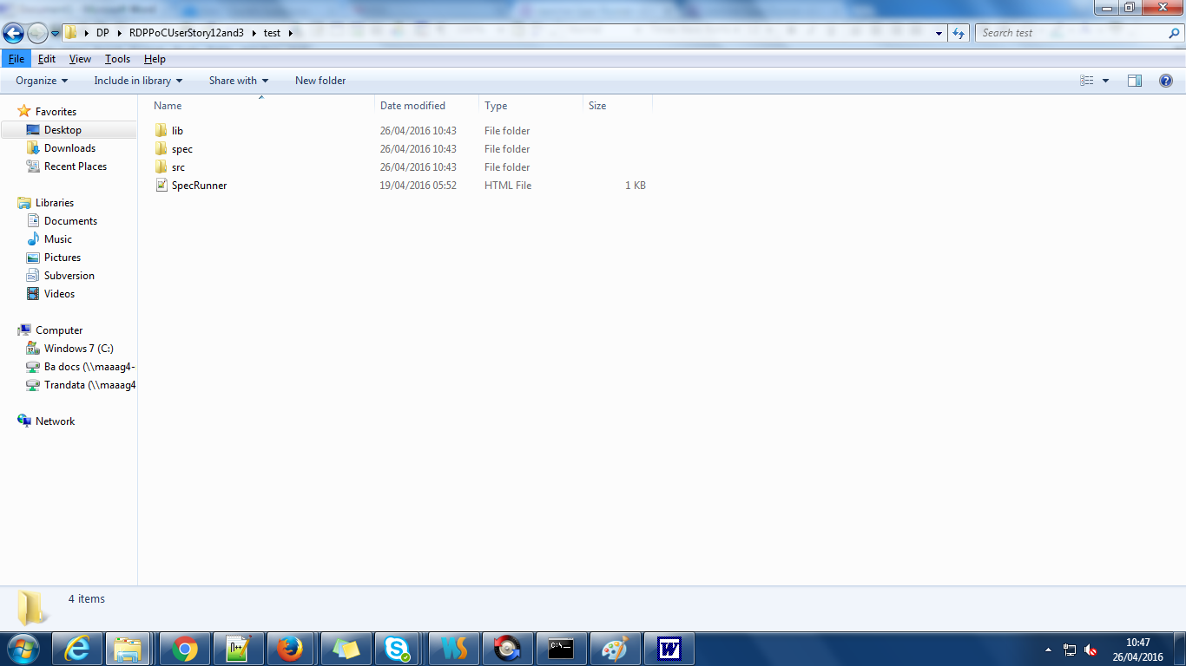

Run the jasmine case by open the SpecRunner.html

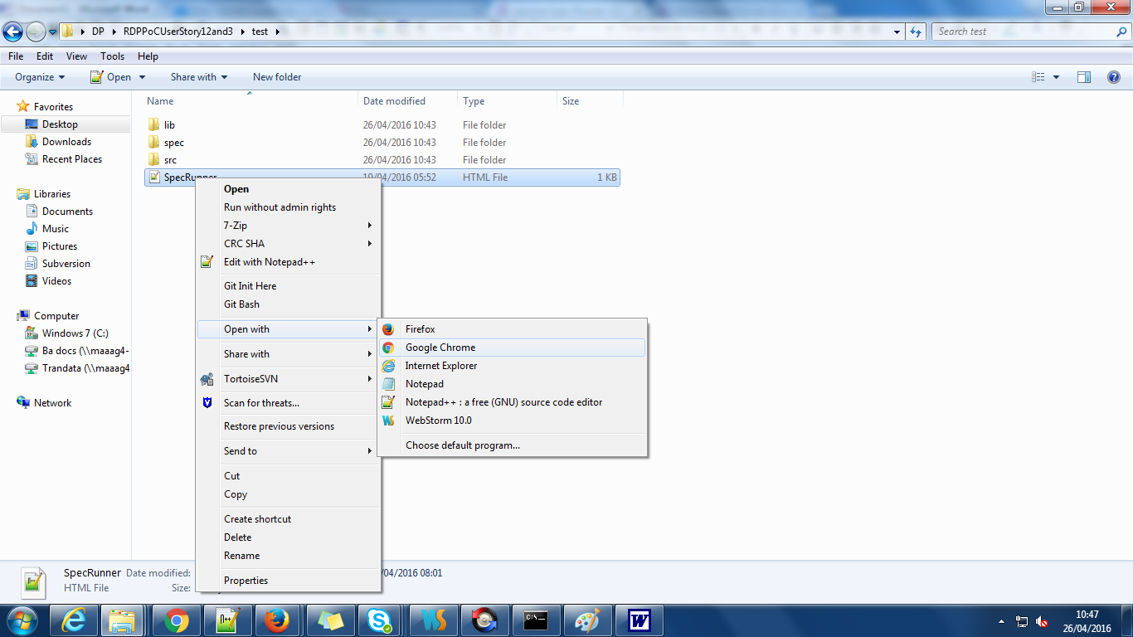

Find the script which we are doing to jasmine test case in src folder

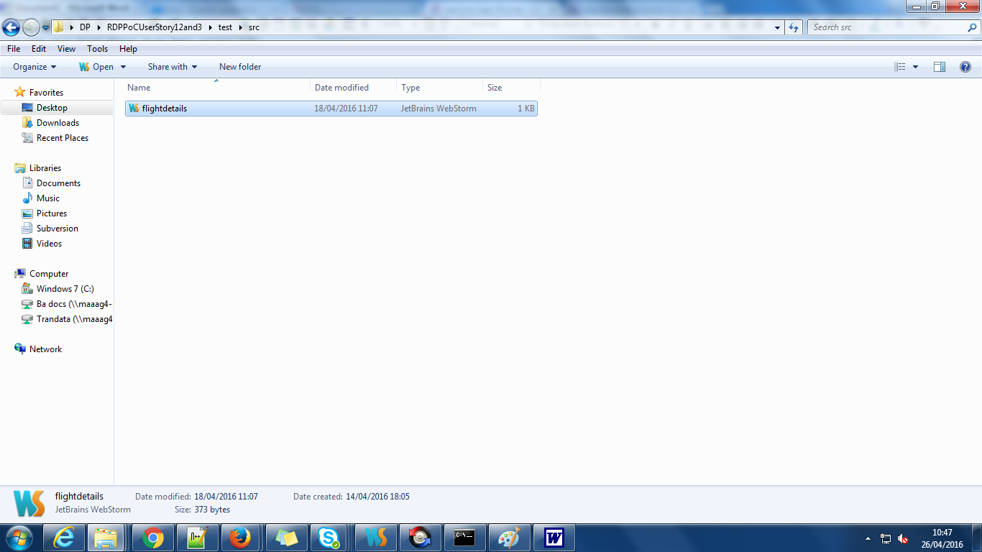

Find the Jasmine testcase inside the spec folder 